“Do not be anxious about anything, but in everything, by prayer and petition, with thanksgiving, present your requests to God.”
-- Philippians 4:6
- All relevant work must be shown for full credit.
- Copying work from another source is plagiarism and carries serious penalties.
- Calculators are permitted, but no notes, text, laptops, or PDAs. Cell phones should be muted and left in your pocket or bag. If your calculator has statistical functions (e.g. mean, variance), you are asked not to use those functions on this test.
- Use of electronic dictionaries is not allowed; please feel free to raise your hand if you wish clarification on a question.
Total marks: 65
Word Problems:
- Mark each of the following statements as either descriptive (D) or
inferential (I). [3]
  - The odds of being struck by lightning are about 700,000 to 1. _____
Inferential
  - 14.5% of all cancer cases in 2001 were lung cancer. _____
Inferential
  - 28.5% of female cancer cases reported in the
Canadian Cancer Statistics 2005 study were breast cancer. _____
Descriptive
- Mark each of the following variables as nominal (N), ordinal (O), discrete (D), or continuous (C): [5]
  - The brightness of a flashlight in lumens _____
Continuous
  - The number of people in a hockey stadium _____
Discrete
  - A student’s hometown (city of birth) _____
Nominal
  - The final letter grade for a course at TWU _____
Ordinal
  - The correct answer to a multiple-choice question _____
Nominal
- Describe an example of two events that are mutually exclusive. Be sure to describe the complete sample space as well. [2]
S = all people; A = male, B = female.
S = mice, A = tails shorter than 3cm, B = tails longer than 5cm
- Assume the table below represents the raw data for an experiment measuring wind speed at a particular airport. Draw a frequency histogram, classifying the data by tens of kph. [3]
5 kph | 8 kph | 17 kph
21 kph | 22 kph | 32 kph
32 kph | 37 kph | 42 kph
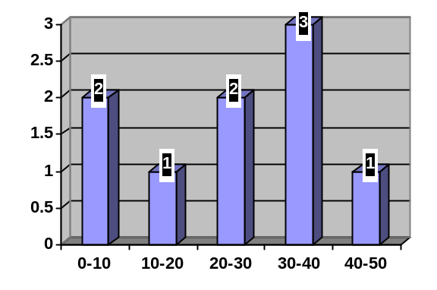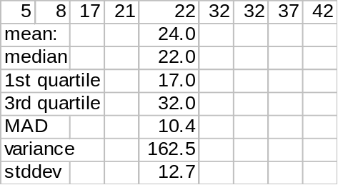
- (Show all work and draw a box around your final answer.) Using the same data from the previous problem, give the
  - Mean [2]
24
  - Median [1]
22
  - First quartile (1/4) [1]
17
  - Third quartile (3/4) [1]
32
  - Mean absolute deviation (MAD) [2]
10.44
  - Variance [4]
162.5
  - Standard deviation [1]
12.7
- Draw and label a boxplot of the data in the preceding problem. [2]
min = 5
1st = 17
med = 22
3rd = 32
max = 42
- Say that in a certain town 1/3 of the people vote Conservative, and the odds that a townsperson drives a car more than ten years old are 3:7. If you pick a random townsperson, the probability that that person is a Conservative driving a car more than ten years old is 10%. In this town, is voting Conservative independent of driving a car more than ten years old? Why or why not? [4]
Yes, independent.
Let A= Conservative, B = old car.
P(A) = 1/3, P(B) = 3/(3+7) = 30%.
P(A)P(B) = 10% = P(A∩B)
so A and B are independent.
- Consider a fair six-sided die (singular of dice).
  - What is the probability of rolling a “1” twice in a row? [1]
(1/6)(1/6) = 1/36
  - If we roll the die twice, what is the probability that the two numbers add up to a total of 5? [3]
There are four possibilities: (1,4), (2,3), (3,2), (4,1).
Each possibility has prob. 1/36, so the total prob. is 4/36 = 1/9.
  - Say that we roll the die five times, and get a “1” every time. We roll the die one more time. What is the probability that we get a “1” on this roll? [2]
Still 1/6
  - Say that we roll the die six times. Are we guaranteed to roll a “1” at least once? [1]
No, the probability 1/6 just means that in the long run
1/6 of the rolls will be a “1”.
- A bag contains 5 red marbles and one green marble. Three marbles are drawn from the bag, without replacement.
  - Draw a tree diagram representing the sample space (list only outcomes that can actually occur). Annotate your tree diagram with probabilities for each branch of the tree and for each final outcome. [6]
R:5/6
R:1
R:4/5
R:3/4
R:1
G:1/6
G:1/5
G:1/4
(RRR): 1/2
R:1
(RRG): 1/6
(RGR): 1/6
(GRR): 1/6
  - What is the probability of finding the green marble in these three tries? [2]
½ or 50%
  - What are the odds of finding the green marble in these three tries? [1]
1:1
- Let A represent students with financial aid. Let B represent students from BC. Translate each of the following statements into P() notation and draw Venn diagrams in the boxes provided, shading in each region described:
  - 12% of all students are from BC and also have financial aid. [3]
P(A∩B) = 12%
A
B
  - 39% of students are neither from BC nor have financial aid. [3]
P( (A u B)^{C} ) = 39% (complement of union)
A
B
  - 25% of BC students have financial aid. (No Venn diagram needed.) [3]
P(A | B) = 25%
- Given the information in the preceding problem, what percentage of students are from BC? [3]
P(B) = P(A∩B) / P(A | B) = 12% / 25% = 4x(12%)
= 48%
- What fraction of students have financial aid? [2]
P(A) = (1- P((A u B)^{C})) – P(B) + P(A∩B)
= (1 – 39%) – 48% + 12%
= 25%
- Are the two events A and B independent? Why or why not? [3]
Yes, independent:
P(A) = 25% = P(A | B)
- Are the two events A and B mutually exclusive? Why or why not? [1]
No: P(A∩B) = 12% is not zero.

